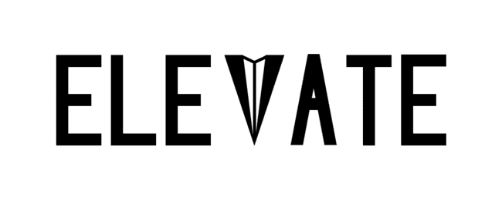
Students connecting for shared success

CS 147 Fall 2024
Riley Pittman, Ginelle Servat, CJ Indart, Grace Miller
December 8 2024

Table of Contents

Project Name & Value Proposition 4
Team Member Names & Roles 5
Problem & Solution Overview 6
Needfinding 7
I. Interviews 7
II. Synthesis 8
POVs and Experience Prototypes 12
I. Final HMW Statements 13
II. Top Brainstormed Solutions 13
III. Experience Prototype Briefs 14
Final Solution: Elevate 19
Tasks 20
Design Evolution 21
I. Initial Sketches 21
II. Low-Fidelity Prototype 23
III. Usability Testing 26
IV. Medium-Fidelity Prototype 27
Values In Design 34
Final Prototype Implementation 36
Reflection 37
Next Steps 37

Project Name & Value Proposition

Project Name
Elevate

Value Proposition
Students connecting for shared success

Team Member Names & Roles

Riley Pittman
User Researcher + Developer

CJ Indart
UI/UX Researcher + Developer

Ginelle Servat
User Researcher + Developer

Grace Miller
UI/UX Researcher + Developer

Problem & Solution Overview

Students searching for jobs and post-graduate career opportunities often feel isolated, unmotivated, and alone.

Elevate is a social networking and career development platform designed to help job-seeking young professionals find community, motivation, and mutual accountability surrounding the job search. By joining a group of prospective professionals seeking jobs in similar fields, creating and sharing personal goals to move them towards their goals, and participating in weekly check-ins surrounding their mental health and big-picture trajectory, Elevate’s users form the habit of regularly communicating with a supportive group of peers about both their wins and their losses as they look for a job. We hope that this platform will provide a sense of community and teamwork that will both comfort and motivate young professionals as they race to keep up with the fast pace of their personal job search.

Needfinding

Interviews

Our team began the design process with zero expectations for where our project would go. Since our team is composed entirely of upperclassmen and beyond (2 seniors, 1 junior, and 1 coterms), we decided to start out our needfinding process by exploring major mental health stressors for people similar to us: students between the ages of 20-24 who were preparing to transition from college into the workforce.

We interviewed a total of six participants. In our initial round of generic needfinding, we conducted four interviews: “Sara” (a graduate student studying school counseling at the University of Iowa), “Alexandra” (a community college student from North Miami), “Emily” (an undergraduate student-athlete at Stanford), and “Trevor” (a recent Santa Clara University graduate and behavioral therapist seeking work in Menlo Park). All of these interviewees were friends or acquaintances of members of our team whom we asked if they’d be interested in calling or getting coffee for 45 minutes to discuss their mental health for a project. Almost across the board, we found that the greatest stressor affecting our interviewees was some element of the job search; the only participant who did not express this sentiment was “Alexandra,” who told us that she actually tended to participate in escapist activities like concert-going to avoid the stress of looking for a job and feared that this would negatively affect her later in life.

To our surprise, however, the main driver of stress surrounding the job search that our interviewees expressed wasn’t the sheer issue of getting hired. In fact, many of them seemed to be confident that they would at least get a job. Instead, our participants disproportionately worried about finding the job that was right for them (“Trevor”), having a good quality of life post-graduation (“Sara”), and balancing the job search with their busy schedules and social lives (“Emily”). Going into our second round of interviews, we realized that we needed to go beyond the issue of just getting a job to explore targeted, less-discussed stressors surrounding the job search.

In our second round of interviews, we spoke with “Sharon,” a young Stanford graduate working professionally as a career coach, and “Julia,” a salesperson early in her career and working full-time in Seattle. We got in contact with “Sharon” at the recommendation and connection of our CS 147 TA, Gray, and Julia through one of our team members’ siblings. In this round of interviews, we asked more targeted questions about the interviewees’ personal experiences and big-picture opinions about major stressors associated with looking for a job out of college. These two interviews gave us insight into a crucial new idea: the job-hunting workshop.

Synthesis

To process the information we gained in our needfinding interviews, we created empathy maps for each of our interviewees. For the last two interviews, we synthesized each participants’ quadrants into concise statements that reminded us of the interview’s main takeaways.

Round 1 Empathy Maps
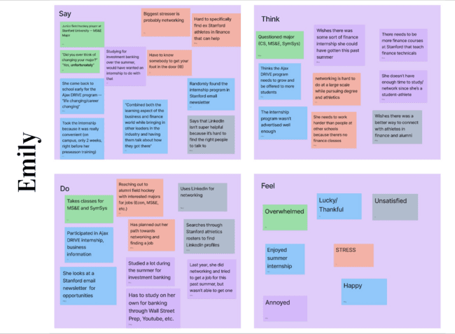
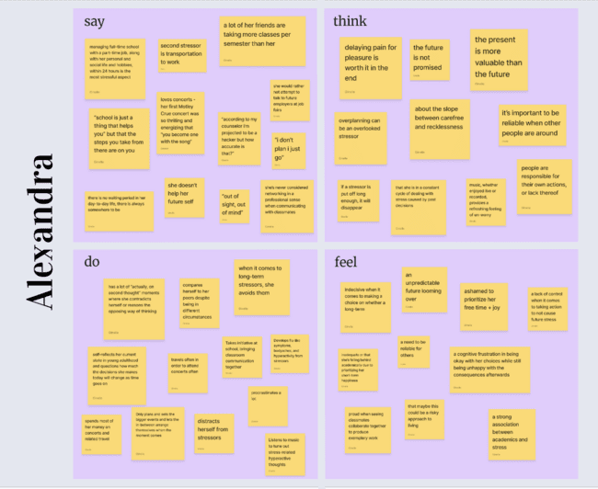
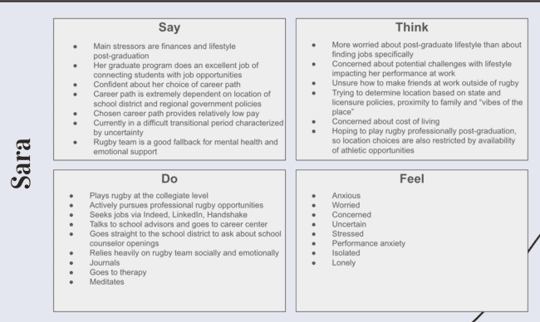
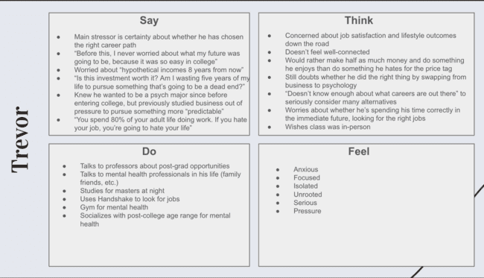

Round 2 Empathy Maps
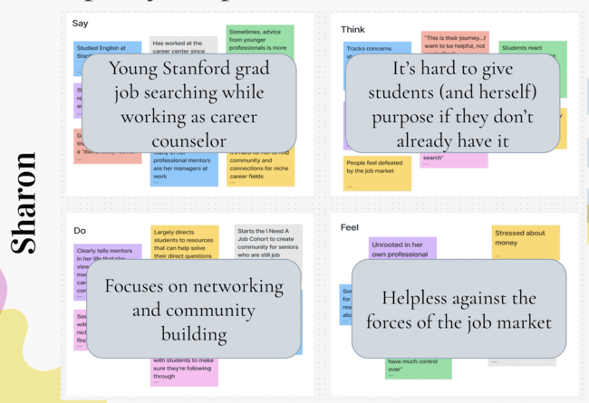
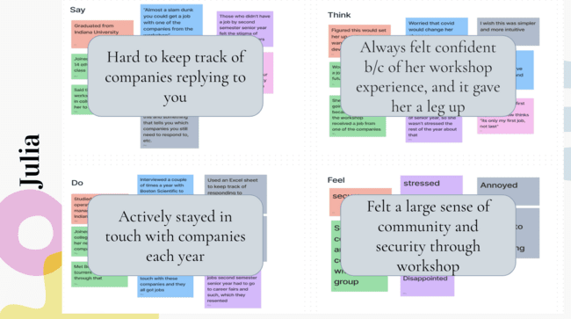

To our surprise, our interviews revealed that job-seekers were primarily concerned about deadline accountability, finding the right job for them, and feeling lonely and discouraged during the job search. Additionally, we found that every interviewee who was involved in a sports team or a job-hunting workshop felt a significantly lower stress level surrounding getting a job. The significant impact of community on mental health surrounding the job search gave us an exciting direction for our project that we explored through POVs and HMWs.

POVs and Experience Prototypes

As a team, we decided to focus on our most insightful interviews, which we reasoned would lead us to a wider range of points of views (POVs), and continue ideating from there. We developed and refined a total of four POV statements: one from Trevor, one from Sharon, and two from Julia’s interview.

Trevor’s POV
- We met Trevor, a recently graduated behavioral therapist working in Menlo Park
- We were surprised to notice that despite already being out of college, Trevor was far more concerned about quality of life and whether he had an accurate gauge on what job was best for him than he was about getting hired
- We wonder if this means Trevor feels disconnected from good information about career options and trajectory.
- It would be game-changing to help Trevor create the lifestyle he wants.

Sharon’s POV
- We met Sharon, a 2021 Stanford graduate who recently left her two-year position as a career coach for Stanford CareerEd and is now job seeking.
- We were surprised to notice that despite working professionally in career services, Shannon still feels uncertain about what she should do with her own life and career.
- We wonder if this means she’s worried the next step in her career won’t help her achieve her life goals.
- It would be game-changing to help align professional goals with life goals.

Julia’s first POV
- We met Julia, an Indiana University graduate currently working for Boston Scientific in medical device sales.
- We were surprised to notice that she missed a second round interview because she missed the email in her inbox.
- We wonder if this means she felt overwhelmed by the amount of emails in her inbox.
- It would be game-changing if people never had to worry about missing opportunities because of a cluttered inbox.

Julia’s second POV
- We met an Indiana University graduate currently working her first job at Boston Scientific, which was offered to her through a workshop.
- We were surprised to hear some of her friends felt isolated and behind in the post-graduate job search, Julia felt more supported due to the workshop
- We wonder if this means that community strongly influences confidence or anxiety in the job search.
- It would be game-changing to create a way for students to feel connected and supported during the post-grad life.

Using these POVs, we set out to generate “how might we” (HMW) statements; our process incorporated rapid brainstorming, which generated a total of 34 HMWs from the latter three POVs. During this, a few HMWs stood out to us—these have been bolded.

From Sharon’s POV, how might we…
- connect students with career professionals who are willing to give them advice in an approachable context?
- expose students to opportunities in niche career paths?
- show students a wider variety of options?
- connect students with professionals with whom they share things in common?
- help students identify their strengths and connect it with career paths?
- help students match their ideal lifestyle and income milestones to a career?
- help students share and learn from each other’s interests and journeys?
- create clearer avenues to self-employment?
- demystify the job market for new graduates?
- make sure people meet their life goals?

From Julia’s first POV, how might we…
- automatically flag emails related to critical opportunities?
- make email inboxes less visually overwhelming?
- remind people of important emails?
- make mail-checking a habit?
- make the interviewing process more predictable?
- make the job process not rely on emails?
- prioritize important emails in a user’s inbox?
- create a smarter system for filtering emails?
- redesign email notifications to capture the user’s attention?
- reliably auto-discard junk emails?
- make checking emails more engaging?

From Julia’s second POV, how might we…
- leverage workshops to foster a sense of community in the job search?
- make job applications a social activity?
- make the job application and search process enjoyable?
- make the job search not feel like a race?
- motivate students through the job search process?
- help students applying to jobs together feel like a team?
- use community to boost confidence?
- make workshops more common as pre-graduate professional training?
- create buzz surrounding referring one another to jobs/sharing opportunities?
- connect college students who are seeking similar jobs?
- create a network of unemployed college graduates?
- encourage students to actively stay connected once they’ve met?
- encourage collaboration among students rather than competition?

- Final HMW Statements
As our next step, we selected three of the nine bolded HMW statements via popular vote and team discussion:
- How might we make checking emails more engaging?
- How might we make students applying to jobs together feel like a team?
- How might we help students match their ideal lifestyle and income milestones to a career?
During this decision, we wanted to avoid having our HMWs be similar to each other, in order to give us a greater scope for possible solutions.

II. Top Brainstormed Solutions
With our solidified HMWs, our team got to brainstorming again, coming up with 11 statements per final HMW. Then, we narrowed down our ideas; the top three solutions we had at the end of this process were the following:
- Continuous scroll application for daily work emails
- Dating app-style platform that matches students into pods of 5-10 students seeking similar careers
- Career database searchable by criteria important to the user

Below are the original lists of brainstormed solutions, including some bolded that almost made it to the final cut.

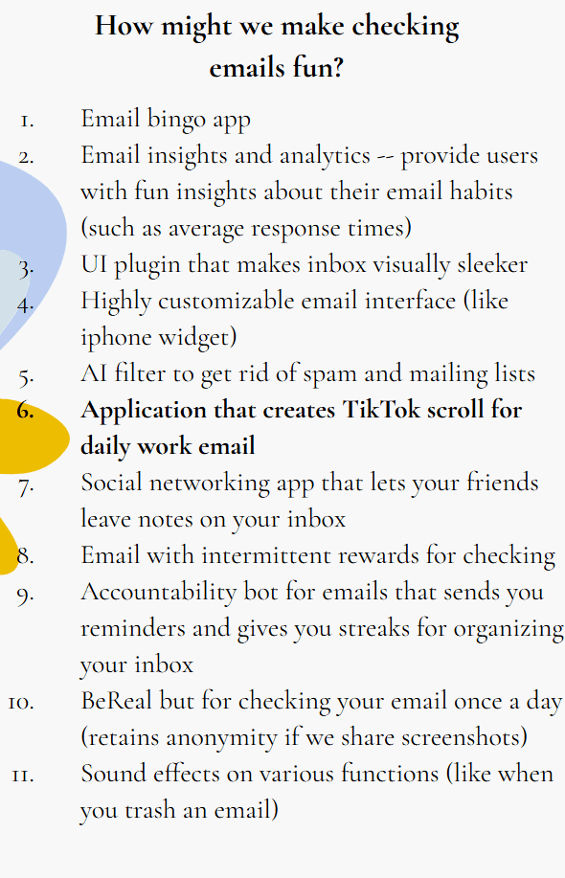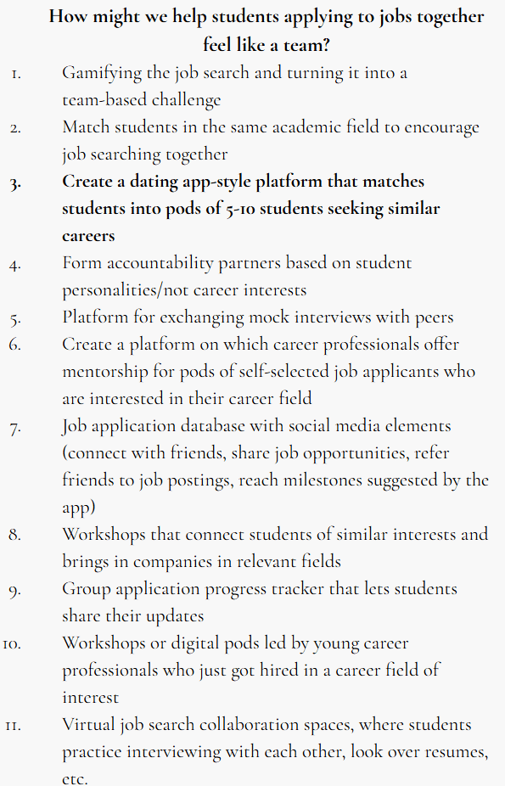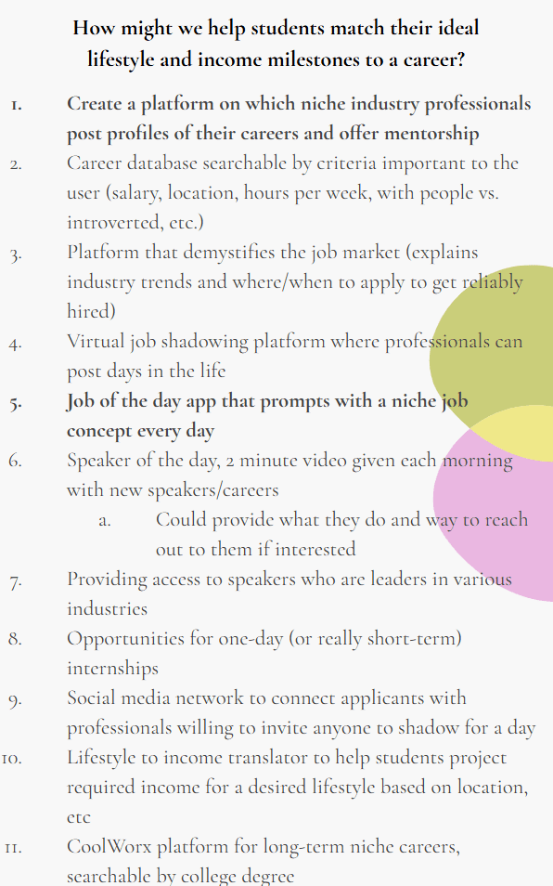

III. Experience Prototype Briefs
We then developed an experience prototype from each top solution, and tested a critical assumption from each. These assumptions give us a taste on the feasibility and reality of implementing the solution if we were to move forward with it.

- Email Reels

Assumption: emails in this format will be able to hold users’ attention.

Setup: had our testers look at a common email interface (e.g., Outlook, Apple Mail) and a pre-recorded, continuous scrolling interface. We asked them to compare the two interfaces and give their opinion on which one was more intriguing and which one they remember more content from, as a way to measure attention via short-term memory.

Participants: three randomly selected Stanford undergraduates, chosen from a dense location on campus.

Findings and Implications: Our testers appreciated the new design, noted that they could see themselves using this, and most importantly, did remember more specific information from the tested (reels-style) interface. However, we noticed some testers had to scroll within each reel to view the full email and received comments on the difficulty of viewing full inboxes with lots of emails. This had us thinking that taking into account the content visibility of the emails plays a huge role in the efficiency and effectiveness of grasping content from our idea.

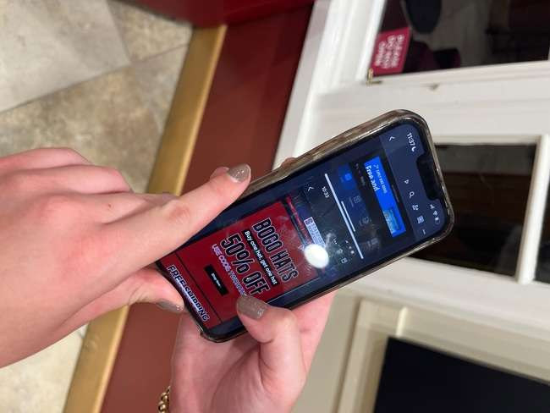
Tester viewing the common email interface (left), then the scroll interface (right).

- Speed Dating App

Assumption: students want to collaborate instead of compete with their career matches.

Setup: find two people looking for similar jobs, have them meet, talk for 5 minutes, then ask them questions about their experience.

Participants: four randomly recruited Stanford undergraduates, making two pairs/runs of the prototype. One pair included students in the same academic year, while the other were of mixed grade/year levels.

Findings and Implications: feedback from our testers communicated that connecting with students job searching in a similar field raises morale and feelings of hope; for example, participants were willing to connect further after the first conversation. Most importantly, we did not notice any undertones of competition within both pairs. However, seeing how only one pair exchanged contact information, it was a possibility that mixing ages and demographics could reduce potential competition.

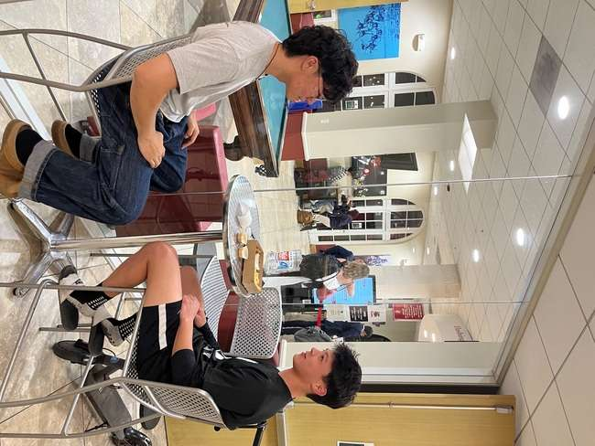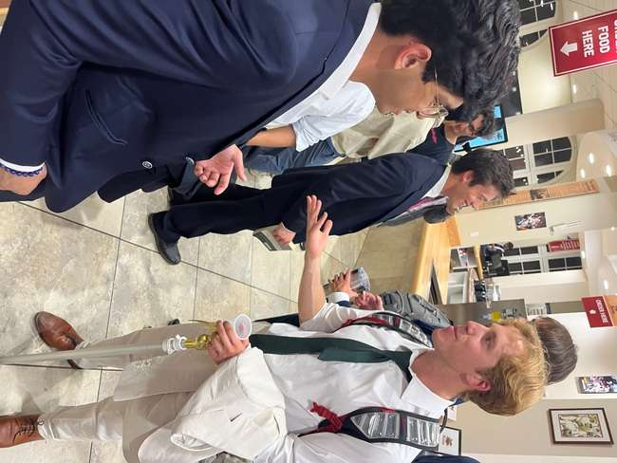
Our two pairs amidst connecting

- Career Database

Assumption: students who don’t know what job they want post-college, do know what lifestyle they want.

Setup: we developed and sent out a Google Form that asks about ideal lifestyles, ranging from location and city-town environment to professional culture preferences, and their ideal career paths. We then analyzed these to determine any patterns, correlations, or outlier details.

Participants: six remotely recruited Stanford undergraduates.

Findings and Implications: from our respondents, most were unsure of their desired job title, which did qualify them as passing half the assumption. We learned that most aim to align work with lifestyle preferences, and that these lifestyle preferences were concrete. This means students know the lifestyle they want, but not the career path, which lends to a greater idea of fitting work into one’s life, rather than life into one’s work. However, our method and carry-out of this prototype prompted further testing to explore whether a preference-filtering, constructed database would attract students rather than a preference self-report.

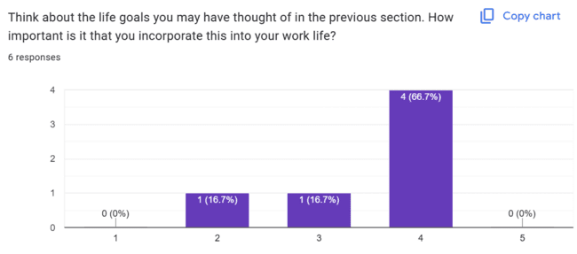
Select question from our third experience prototype, including results

Final Solution: Elevate

Description:
A networking and career development platform that allows job-seeking young professionals to connect with one another and find community, accountability, and motivation in the job search.

Rationale:
Our interviews revealed that by far the most significant factor impacting the mental health of young professionals looking for jobs was a lack of community. Interviewees who lacked a supportive community surrounding the job search tended to avoid the subject (“Alexandra”), while participants who had sports teams to provide community or workshop groups to help keep them on track (“Sara,” “Julia,” “Emily”) seemed to be overall happier and more confident about the future. Also, the career coach we interviewed (“Sharon”) shared that she personally had identified the need for and founded an in-person job-seeking workshop at Stanford, with positive results. Through Elevate, we hope to virtually simulate the experience of working as a team alongside a job-seeking workshop to provide community and motivation for job-hunters who might not otherwise have the opportunity to collaborate.

Target audience:
Impending or recent college graduates seeking full-time jobs and current college undergraduates seeking internships and part-time opportunities.

Who might be left out:
Mid-career job seekers; job seekers without college degrees; job seekers who don’t own smartphones

Ethical implications:
- Safety: All social media platforms are susceptible to harassment and abuse without good moderation
- Equal Access: Important to consider how design choices make the app more or less accessible to mid-career or non-collegiate job-seekers

Tasks

- Simple Task: Match with a group
During onboarding, Elevate users voluntarily enter personal information that allows them to match with a group of 4-7 nearby young professionals seeking job opportunities in similar areas. Group members can view each others’ profiles and communicate with one another through the Group Chat. We intentionally refrained from implementing non-group direct messaging capability to encourage group members to collaborate as much as possible.

- Medium Task: Set and share personal goals
Once they’ve matched with a group, Elevate users can explore their Personal tab. In the Personal tab, users can set deadlined goals for themselves, sorted by priority. goals are intended to function like a to-do list to keep users on track in the job search. Your goals are automatically shared with your group to encourage users to hold one another accountable and engage in friendly competition.

- Complex Task: Complete and share weekly check-ins
At the end of each week, Elevate users are invited to complete a personal weekly check-in. Rather than exploring the concrete details of what users accomplished that week, check-in questions focus on the user’s big-picture mental health updates and job search trajectory. Weekly check-ins are shared with group members and can be accessed through a button on each user’s profile page.

Design Evolution

Initial Sketches

Initial sketches for Elevate explored three possible realizations: an Apple Watch implementation, a mobile app, and a desktop version.

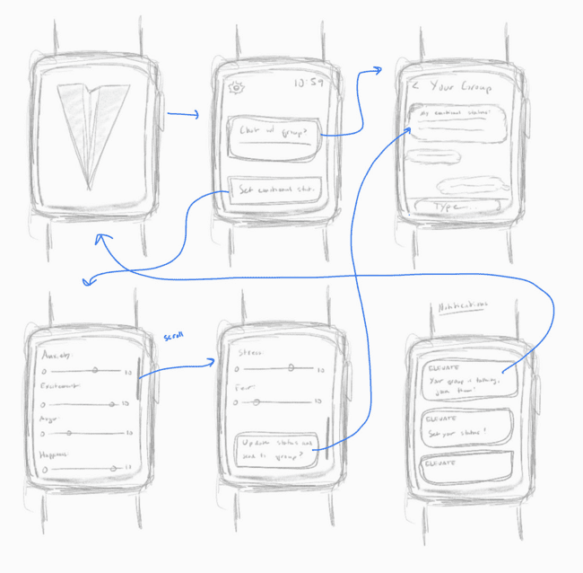
Concept 1: Apple Watch realization

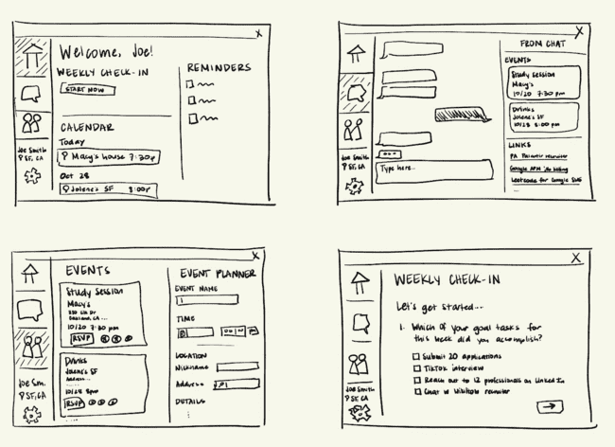
Concept 2: Desktop realization

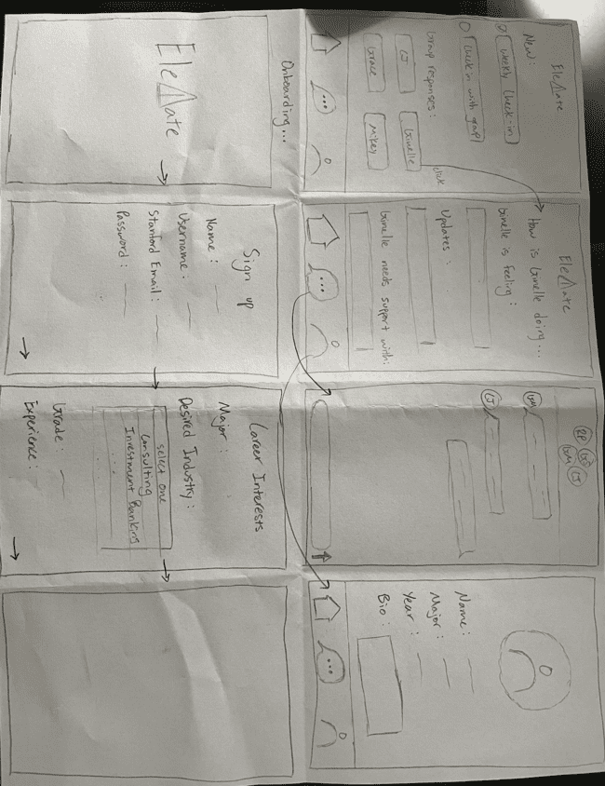
Concept 3: Mobile app realization
We liked the portability, urgency, and access to users provided by the Apple Watch implementation. Because Elevate revolves around communication and requires constant buy-in to the community to function, we liked the idea of expressing the app’s main accountability functions mainly through notifications. However, we quickly realized that more elaborate tasks central to the app’s function, such as setting personal goals and completing weekly check-ins, would be extremely difficult to do on such a small interface. Additionally, implementing Elevate for Apple Watch would significantly reduce our goal audience and eliminate many job-seekers who might own smartphones, but not smart watches. Similarly, we liked the space and ease of organization and typing that came with a desktop implementation, but found the idea of group messaging on a laptop with no cell phone option to be unnecessarily clunky.
After weighing the pros and cons of each option, we settled on a mobile app implementation, which combines the Apple Watch benefits of push notifications and a text-messaging interface for the group chat with the desktop benefit of a reasonably spacious display that makes setting goals and completing check-ins easy. After selecting our implementation, we started on our first low-fidelity prototype.

Low-Fidelity Prototype

We used the Notability app on an iPad to sketch our low-fidelity prototype, then printed it out on 8.5 x 11 sheets of paper. Our low-fi prototype provided functionality for our three primary tasks, shown on the next page.

- Simple Task: Match with a group

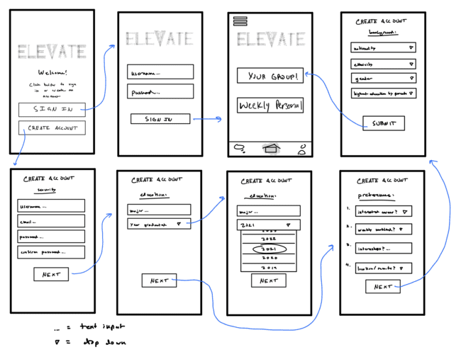
Elevate users fill out a brief questionnaire to match them with a group of like-minded young professionals.

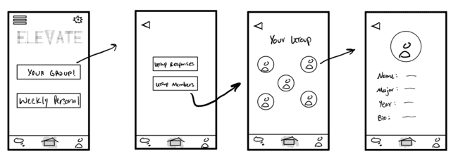
Once matched, users can view their group members through the Group Home page.

- Medium Task: Set and share personal goals

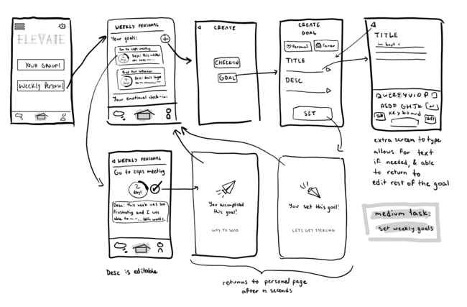
Users set personal goals to keep themselves on track in the job search.

- Complex Task: Complete weekly check-ins

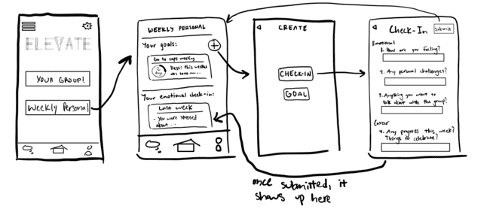
Users are prompted to complete weekly check-ins about their mental health and trajectory.
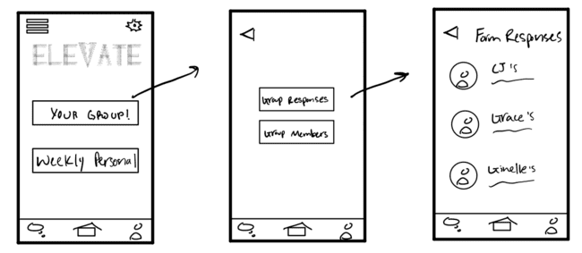
Users can view one another’s weekly check-in responses through the Group Home page.

Usability Testing

We tested our low-fidelity prototype on four users: “Sarah”, a 22-year-old Stanford undergraduate; “Matthew,” age 26; “Kath”, a 24-year-old PhD student at the University of California Santa Cruz; and “Liz,” a 23-year-old PhD student at UCSC. All three of these participants were either friends or friends of siblings who did not receive compensation. Each participant was provided with a brief explanation of the purpose of Elevate and a summary of the three tasks. Participants were then asked to think out loud as they attempted to complete all three tasks. Afterwards, we asked each participant the same set of questions:

- Were there any features that were unclear? Not useful?
- How was the UI in ease of use?
- General feedback?
- On a scale from 1-10, how likely are you to use the chat feature? How about the weekly check-in forms? And the goal setting?

We evaluated the effectiveness of the low-fidelity prototype using two criteria: UI intuitiveness, which we measured by counting each participant’s number of mis-clicks, and likelihood to use, which we measured by asking participants to rate how likely they were to use each feature from 1-10.

Results

Across the board, users found the UI to be mostly intuitive. However, almost all users were unaware that they were paired into a group after onboarding and had difficulty navigating to the weekly check-in. Additionally, most users were confused about exactly what tasks they could accomplish on the app from the home screen. Many users also asked about what would happen if they didn’t like a member of their group, or if they wanted to direct message one member individually. Testers averaged around 5 misclicks each, and all of the app’s main features earned likelihood to use ratings of 6-8, with no ratings below a 5. Overall, users expected more visibility and control over group creation, wanted to be able to communicate outside of a group chat, and had difficulty with certain task flows, especially the weekly check-in.
After reflecting on usability testing outcomes, we settled on the following objectives for revision going into our medium-fidelity prototype:

- Rethink weekly check-in task flow, especially where to begin completing the form
- Make group sorting process more visually clear to the user; possibly involve the user more
- Give users more control over the members of their group
- Put more thought into introductory questions on signup

Medium-Fidelity Prototype

We used Figma’s prototyping tool to create our interactive medium-fidelity prototype. We used the tool to hard-code screens for almost all of our app’s functionalities, including all three of our task flows, which are shown in their medium-fidelity realization on the following pages.

- Simple Task: Match with a group

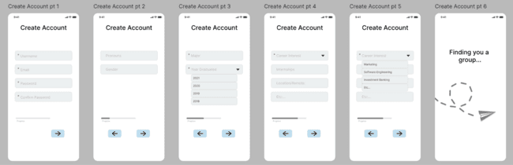
We created a modified onboarding process with less personal questions and mandatory fields indicated.

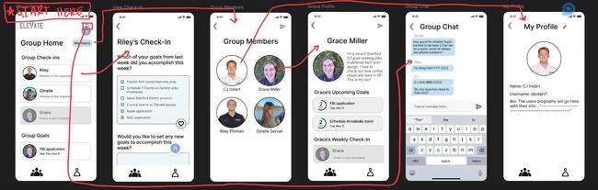
Once members match with a group, they can explore others’ check-ins and profiles and communicate via the group chat. We chose to continue with a group-chat-only design, since this supported collaboration, one of the main values of our design.

- Moderate Task: Set and share personal goals

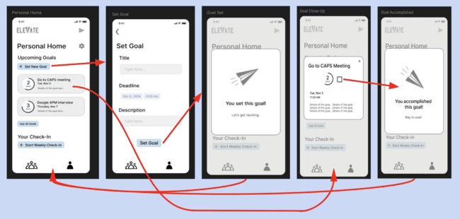
Users can set and view their personal goals via the Personal Home page.

- Complex Task: Complete weekly check-ins

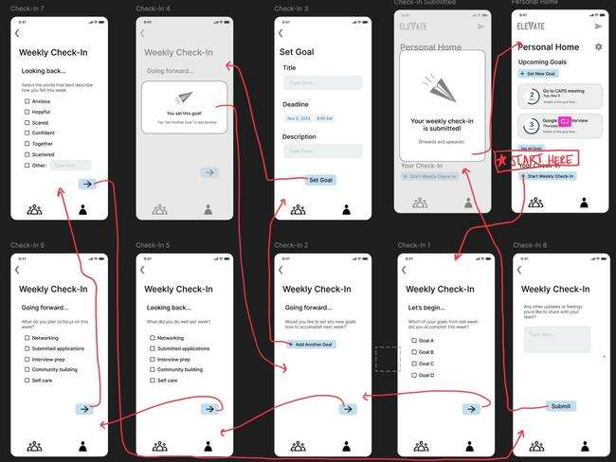
We modified the weekly check-in to be accessible from the Personal Home page.
Heuristic Evaluation

We received heuristic evaluation feedback on our medium-fidelity prototype from another team in CS 147. In total, our medium-fidelity prototype received a total of 61 heuristic violations, 19 of which were rated severe (severity level 3 or 4). The most significant concerns regarded community values, with issues arising surrounding unintentional competition and minimal interactive features. Additional common frustrations included lack of visual differentiation between sections, confusing navigation, lack of clear instructions for app functions, and some minor formatting inconsistencies.
We made 40 total revisions to our medium-fidelity prototype to address these changes. Major revisions made to address severe violations are outlined below:

- Mandatory fields highlighted in onboarding process
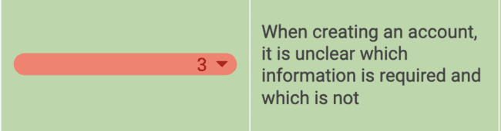
We addressed this issue by adding red asterisks to each mandatory onboarding field, allowing users to voluntarily retain more personal information if they prefer.

- Goal > Target

Users complained that the word “goal” was too big-picture for the to-do-list structure we had created. We modified the word “goal” in the app to the word “target” to more accurately express the intention of this functionality.

- Target/Checkin Info
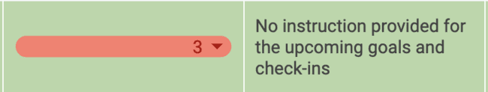
Reviewers felt that it wasn’t clear enough to a first-time user what targets and check-ins were even for. To mitigate this, we provided info buttons to the right of each target or check-in heading, accompanied by pop-ups that explain what targets and check-ins are for in minimal words.

- Edit/delete targets
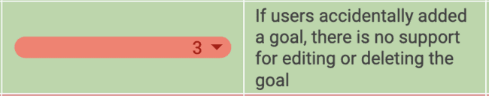
Users pointed out that there was no functionality provided for editing or deleting a goal. To address this, we added an edit button to users’ close-up view of their own goals, with a “delete” option at the bottom of each edit page.

- Edit/leave group

Users complained that if group members didn’t like their teammates, there was no option to modify or leave their group. We fixed this by adding an “Invite Members” button on the group members homepage to allow users to directly add their friends, and listing a “Leave group” option next to Logout in the settings menu to allow users to leave their group entirely and restart the onboarding process from the beginning.

- New profile features

Reviewers pointed out that member profiles provided very little information beyond teammates’ targets and check-ins, which was already provided on the group homepage. To address this, we added university, class year, and current location tags to each user’s profile, along with a downloadable contact card.

- No targets in check-ins
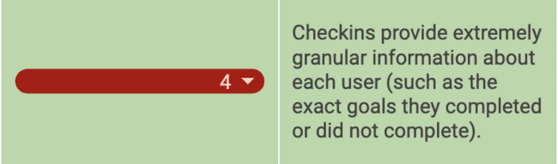
Reviewers’ most significant critique was that the extremely concrete information provided in weekly check-ins would encourage users to compete with one another rather than working together. In response, we re-imagined the weekly check-in to remove all references to specific goals and focus exclusively on mental health and the bigger picture.

Additional Changes

In response to additional T.A. feedback, we made major changes to our medium-fidelity prototype’s Group Home and Personal Home tabs to reduce visual clutter and make the interface more engaging.

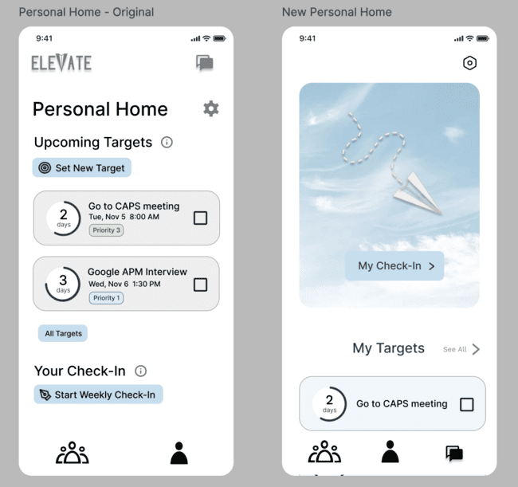
Original personal home (left) vs. new personal home (right)

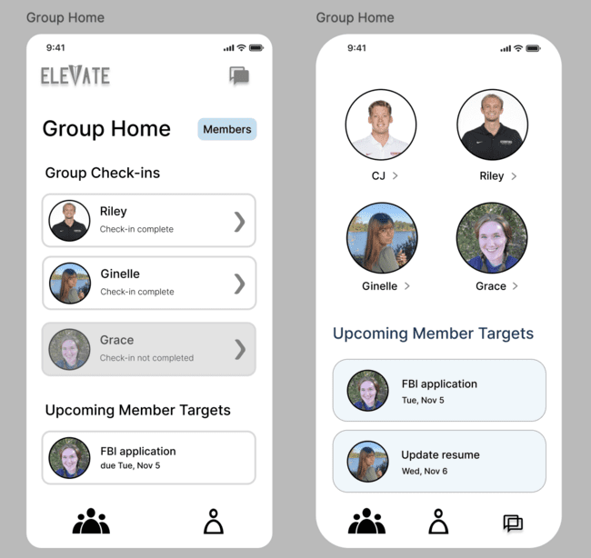
Original group home (left) vs. new group home (right)

We also renamed “group” to “crew,” in keeping with the aviation/paper airplane theme of our interface.

Values In Design

The process of developing Elevate’s design encouraged us to pare down our design values to a core set of principles on which we refused to compromise. We settled on three key values:

- Teamwork
We wanted Elevate users to support one another as a group, with each member of the team equally engaged and acknowledged. To contribute to this goal, we intentionally chose to avoid any direct messaging function, even when subjects brought this up as a point of contention in usability testing. Additionally, we chose to limit each member to one core team, despite debate about whether users should be able to browse and join multiple teams, to encourage group members to buy into their current community instead of shopping for others.

- Collaboration
We wanted to encourage users to lift each other up throughout the job search, not compete. To support this, we did our best to design a platform that would combine users from diverse backgrounds and in variable stages of the job search to support one another without competition. Our user research found that students with different demographics or seeking jobs at different levels (for instance, an internship vs. a full-time job) helped reduce competition, so we did our best to design a system that matches students as randomly as possible. Additionally, we removed all reference to concrete accomplishments from the weekly check-in to encourage users to focus on their mental health rather than their to-do list.

- Transparency & Authenticity
We hope that users of Elevate will quickly build a supportive community and develop meaningful relationships based on authenticity. As a result, we designed weekly check-ins to be mandatory, requiring users to participate in candid conversations early and often.

Tensions
Surprisingly, we found some conflict between teamwork and collaboration. Our user research found that combining students in various stages of the job search, such as a prospective intern with a prospective full-time employee, helped reduce competition–yet this also counteracted teamwork, since graduating seniors, for instance, are likely to feel more community with one another than with a rising sophomore. We did our best to combine these two values by envisioning a system that matches students in similar phases of the job search, but from different universities and backgrounds, allowing students to relate without directly competing.

Final Prototype Implementation

We built our high-fidelity prototype using React Native, Expo, with some backend aspects done using Supabase. We used Apple’s Xcode Simulator and Android Studio to test the app as we developed it.

Wizard of Oz Techniques
Because our high-fidelity prototype is not actually online and has not accumulated a database of real users, we employed a Wizard of Oz approach to “match” users on signups with a pre-set sampling of random users. On login, users see two garbage profiles, James Landay, and one of our team members, which are simply the first four entries in our app’s preloaded database. Additionally, our group chat visually appears to be functional, but doesn’t actually send messages to any other users.

Hard-Coding
We hard-coded multiple elements of the interface to simulate the user experience without fully implementing the backend. Notable hard-coded elements are as follows:
- Regardless of login, the user navigates the app as CJ. The My Profile page is hard-coded to show CJ’s profile.
- Only one user in the Wizard of Oz “crew,” James Landay, actually has a clickable profile. Landay’s profile and weekly check-in responses, which are arranged to show what the app would hypothetically look like if fully implemented, are both hard-coded rather than drawn from a database.
- Although the All Targets page is fully functional, the single upcoming target displayed on the Personal Home page is hard-coded and not related to any sample targets that a test user might input on the All Targets page.

Reflection

Designing and developing Elevate this quarter was a wonderful experience with an intense learning curve. Above all, we learned that listening to potential users is the most important part of the design process, since our entire app stemmed from a single observation that none of us anticipated: the most stressful part of the job search isn’t the actual challenge of getting a job, but the perceived loneliness and lack of community during the process. Additionally, we learned that you can never have too many ideas – we continued to brainstorm design concepts and modify our prototype up until the very last week of the class, resulting in a user interface in our final high-fidelity prototype that wasn’t even completely realized until Week 10. Finally, the structure and pacing of the class, heavily focused on ideation and communication of our designs rather than the actual technical implementation, helped us learn the importance of design and marketing in the tech entrepreneurship space. Even the most brilliant ideas can be easily looked over if they aren’t adequately fleshed out and communicated!

Next Steps

Our high-fidelity prototype still leaves space for the development of additional interactive features, such as reactions and tapbacks on others’ targets and weekly check-in responses or push notifications when team members send you a message or react to your target updates. However, further iterations of Elevate could go on to incorporate additional networking features, many of which were suggested to us by industry professionals at Friday’s expo. An updated version of the app might also allow mentors to sign up and lead or advise groups of 4-7 job applicants. Later versions could even incorporate a tab in which industry professionals can join the community to advise or even hire job seekers. Needfinding and brainstorming additional functions to make the app even more effective could be the next part of the adventure!

